The Big Band Blowout!

With Solo Artist:

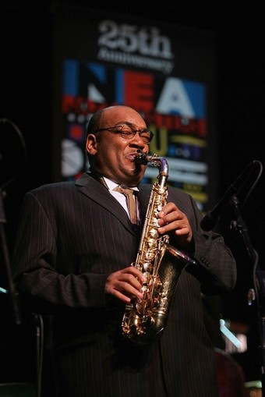
For Ticket Information contact:
JoD Apitz
BBBtix2011@gmail.com
714.701.0987

Yorba Linda Friends Auditorium
May 20th - 7:00p.m. $10

5141 Lakeview Ave. Yorba Linda, CA 92886

